Louth Golf Club | 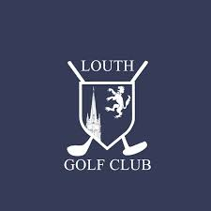

MIXED OPEN  Aggregate Stableford  (Rob Maconachie Trophy) | 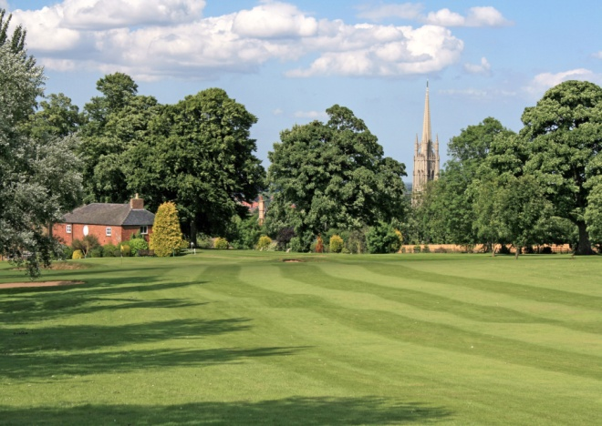

Sunday 5th September 2021

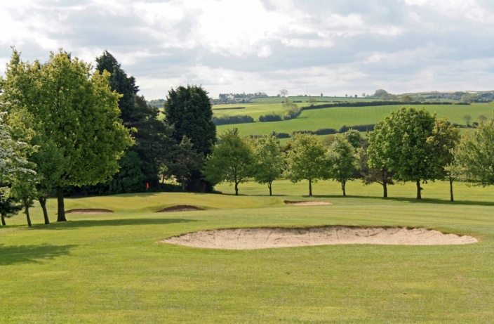 | We invite you to come and enjoy a round of golf in the Lincolnshire Wolds on our scenic parkland course, renowned for its challenging greens.

The format is an Aggregate Stableford
90% handicap allowance

The entry fee is £68 per pair
£38 per pair for Louth members
This includes a 2 course meal & coffee & Halfway House refreshments

Entry form below, or available by emailing acraven24@hotmail.com Closing date – Thursday 26th August
If you require further details, please email, using the above address

 | Louth Golf Club  ENTRY FORM – MIXED OPEN 2021  (Rob Maconachie Trophy)  Aggregate Stableford  Sunday 5th September 2021  The The entry fee is £68 per pair, £38 per pair Louth members | 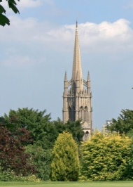

 | Name | Club |  | Handicap
 |  |  |  | Index
Team Player 1
Team Player 2

Contact name ___________________________ Phone no. ___________________

Preferred tee time: ________ we will do our best!

Please supply a contact email address _____________________________________

Please return entry form if possible by email & pay by BACs - Sort Code: 53-81-15, Account Number: 81640706

Alternatively send the entry form with a cheque payable to Louth Golf Club (Mixed), Crowtree Lane, Louth, Lincs, LN11 9LJ

Please indicate your preferred starting time between 11.30am and 12.45pm

Start times will be confirmed on Friday 27th August

